Spring 2015

CIS 4800

Sangeun Lee, Angelyn Arthur, Khadiza Selina, Jaekyum Yoo

Prof. Kannan Mohan

The Computer Information Systems department has requested our team to develop a web-based survey management tool. This tool will enable the various faculty members and Ph.D. students in the department to conduct survey research.

**Project Final Report (Web-Based Survey Management Tool)**

* Use Case Diagram

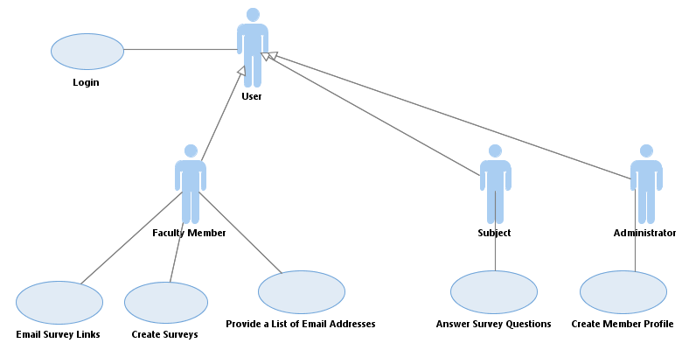

* Use Case Specifications with Activity Diagram (Create Member Profiles)

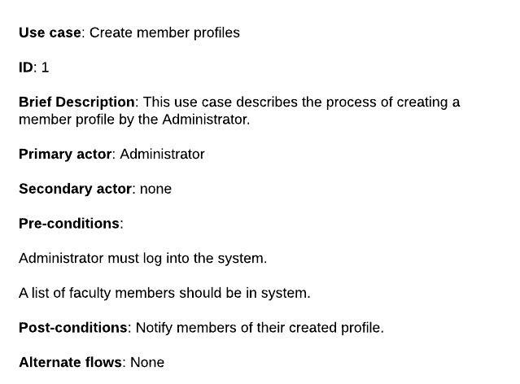

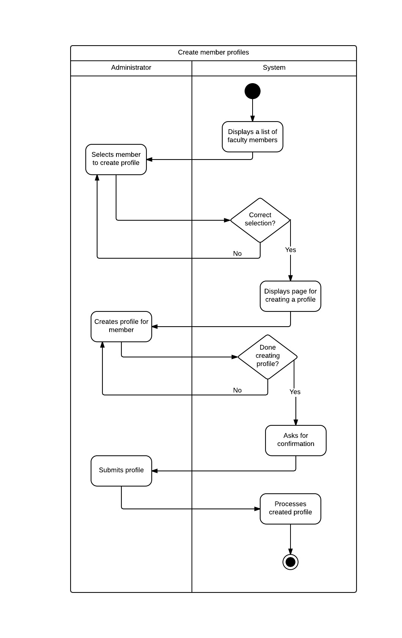

* Use Case Specifications with Activity Diagram (Answer Survey Questions)

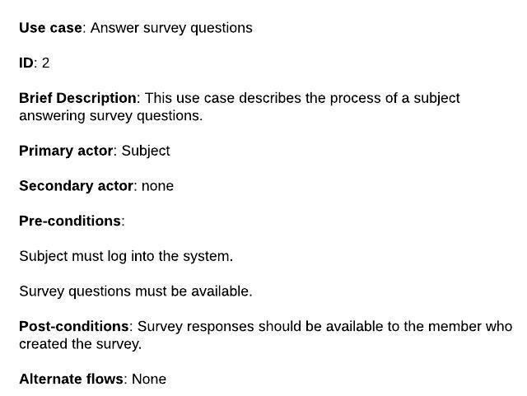

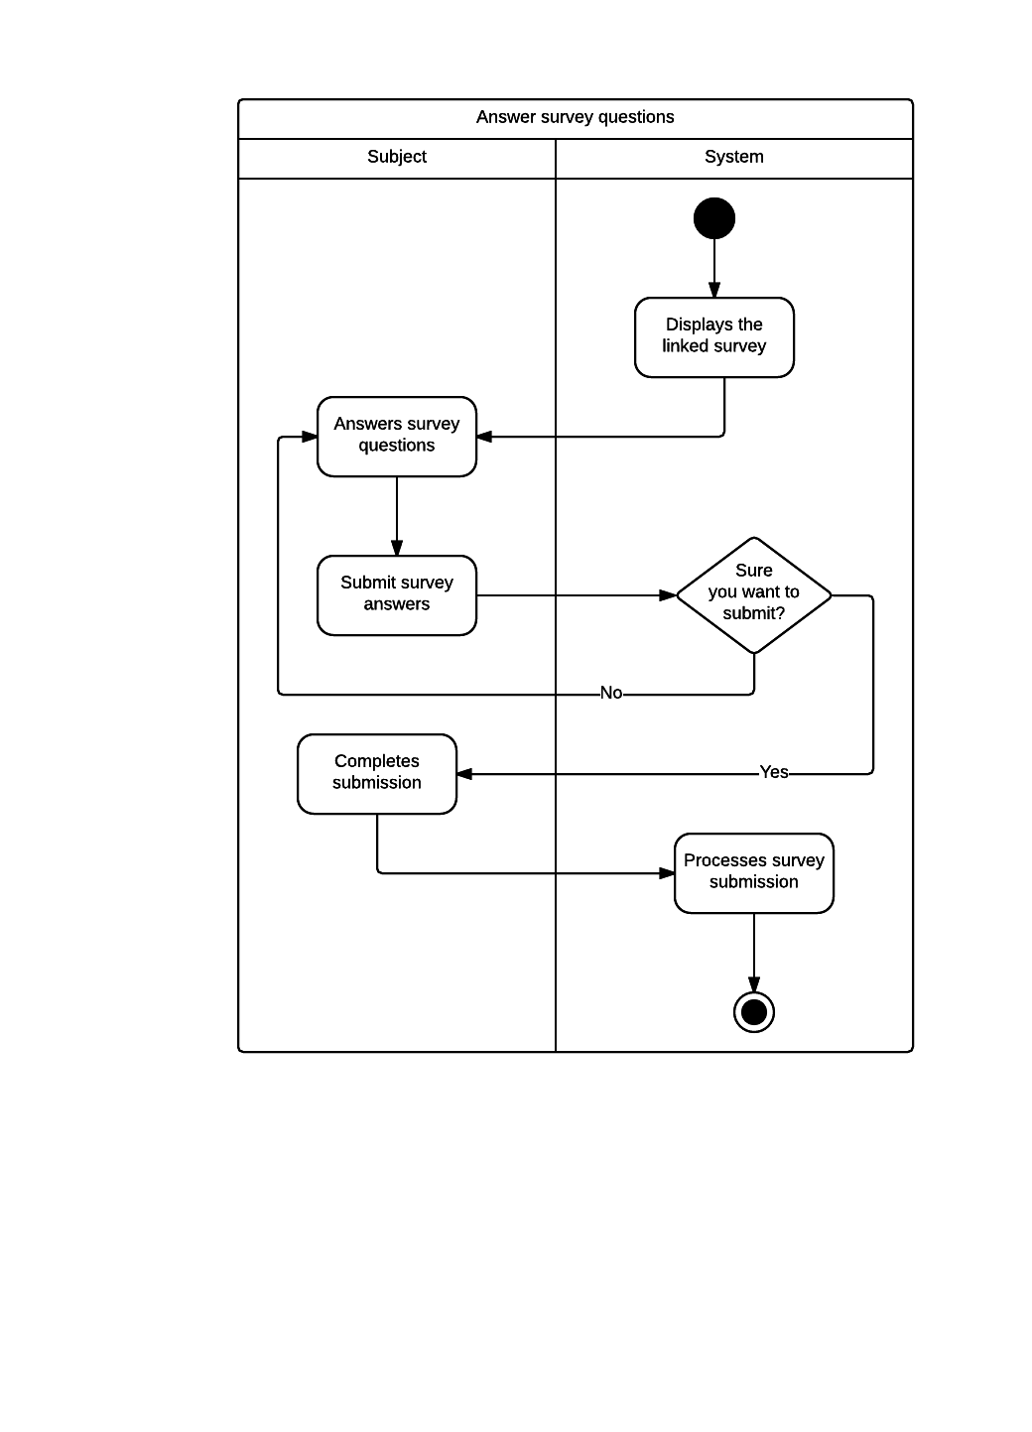

* Domain Class Diagram

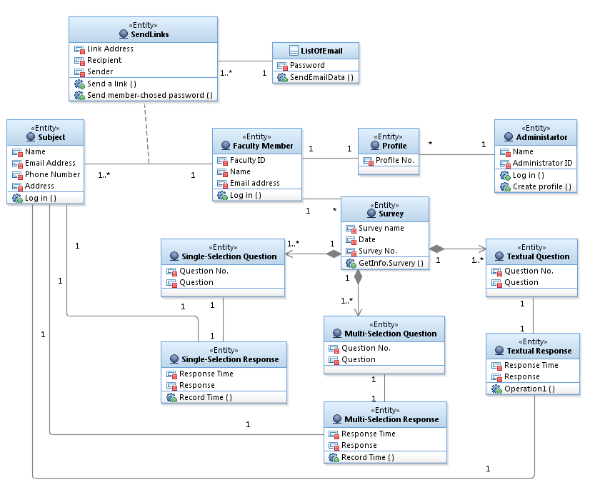

**Phone number, Address attributes need to be added under Faculty Member class

**Record Time ( ) is an operation, not Operation1 ( ) under Textual Response class

* The reason why we could not fix them in the diagram is because by the time we have those issues addressed we did not have access to IBM RA. So our apologies.
* Another Class Diagram for the Sequence Diagrams

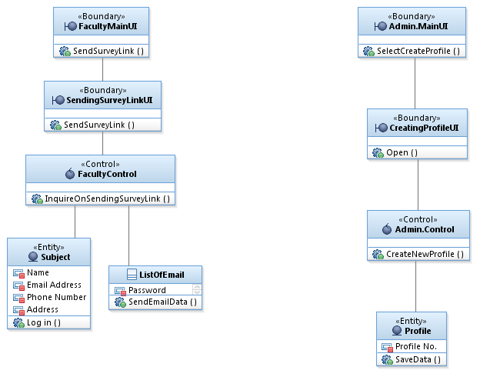

* UI Mockup (Send Survey Link)

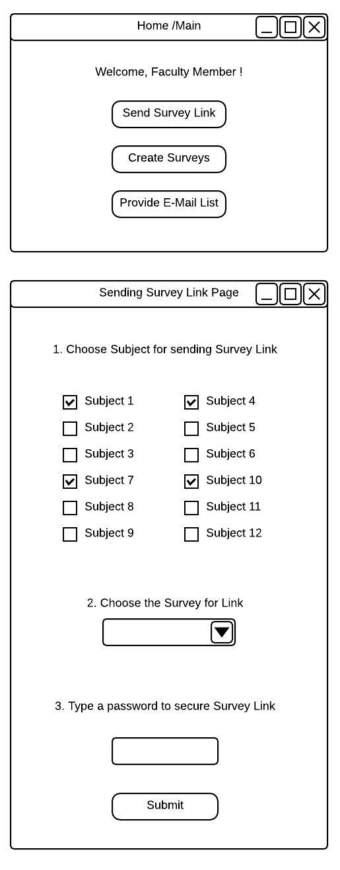

* Sequence Diagram (Send Survey Link)

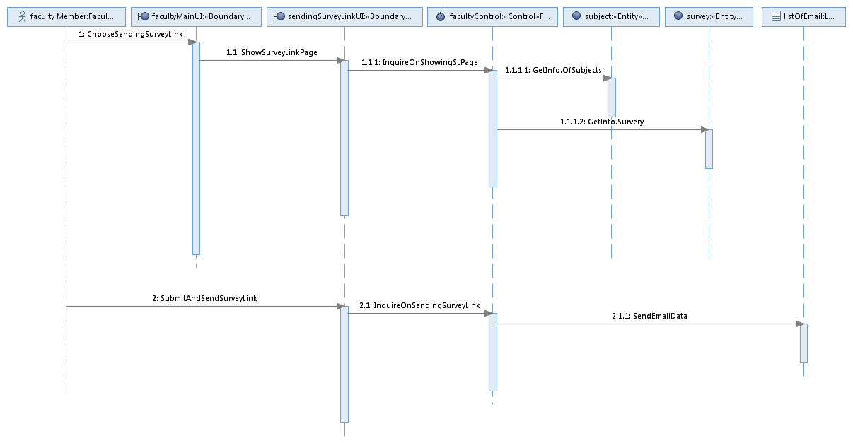

* UI Mockup (Create Member Profile)

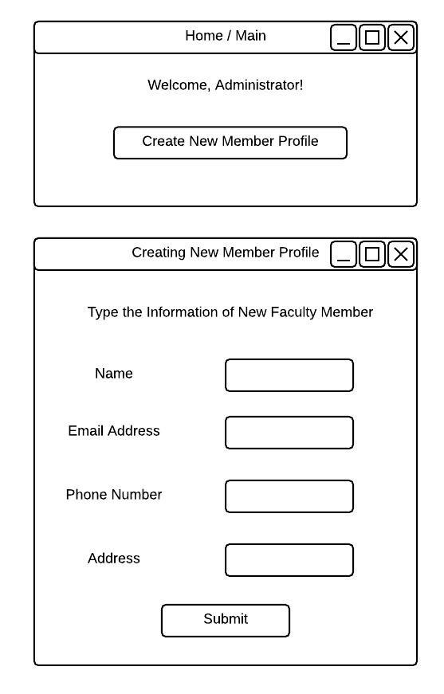

* Sequence Diagram (Create Member Profile)

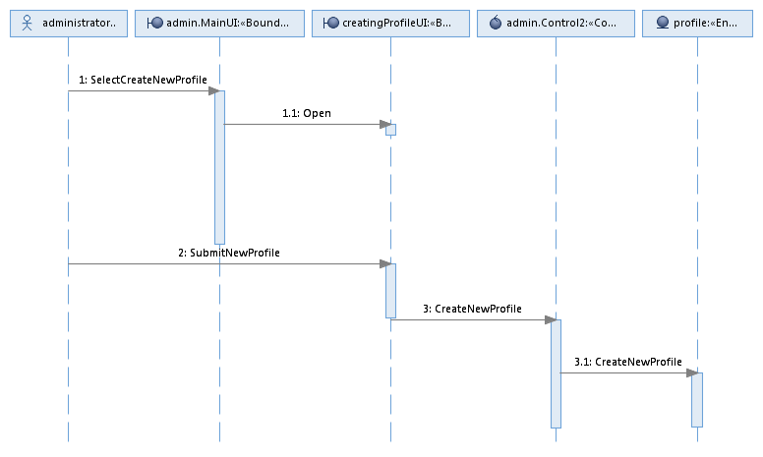

* State Diagram – (Survey class)

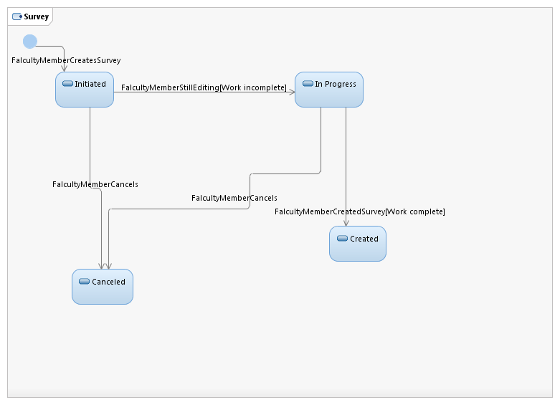

**Reviews & Resolution**

* **From Professor**

|  |  |
| --- | --- |
| **CIS 4800 – Systems Analysis and Design**  **Department of CIS**  **Baruch College** | |
| *Kannan Mohan*  [Kannan_mohan@baruch.cuny.edu](mailto:Kannan_mohan@baruch.cuny.edu) | *Design Review* |

**Score: 91/100**

1. Use Case diagram
   1. Inappropriate interactions

|  |  |  |
| --- | --- | --- |
| **Interaction** | **Description of why it is inappropriate** | **Addressing the issue** |
| Relationship between user and other actors | Shouldn’t this be an inheritance? (-3) | It is supposed to be an inheritance, and we mistakenly put the wrong type of symbol. |

1. Class diagram
   1. Missing associations

|  |  |  |
| --- | --- | --- |
| **Association** | **Description of why it is inappropriate** | **Addressing the issue** |
| Questions and survey | How do we know which question is part of which survey? (-2) | So we created each multiple-selection, single-selection, and textual questions, which are all connected to survey class |

* 1. Inappropriate attributes

|  |  |  |
| --- | --- | --- |
| **Attribute** | **Description of why this is inappropriate** | **Addressing the issue** |
| Response and question | Why are responses and questions mixed up in one class (textual questions)? (-2) | We removed the class with inappropriate attributes, and then we created question and response classes separately. |
| Single selection and multiple selection | The multiple choice class seems to have attributes that may not all be relevant for every object of that class. (-2) | We removed the class as well and created two different classes for single-selection question and multi-selection question. |

* **From Classmates**

|  |  |
| --- | --- |
| **CIS 4800 – Systems Analysis and Design**  **Department of CIS**  **Baruch College** | |
| *Kannan Mohan*  Kannan_mohan@baruch.cuny.edu | *Design Review*  *Alan, Ruki, Eivind, Vatsal* |

**1. Use Case diagram**

*1.1 Missing use cases*

|  |  |  |
| --- | --- | --- |
| **Use case** | **Description of why you need this** | **Addressing the issue** |
| none | - | - |

*1.2 Inappropriate use cases*

|  |  |  |
| --- | --- | --- |
| **Use case** | **Description of why it is inappropriate** | **Addressing the issue** |
| Send Chosen Password | It is not necessary because the chosen password will be sent as a part of the “Email Survey” use case. | This is a matter of how our group decides to do, but considering the class diagram we have, we decided to take this recommendation into consideration. We took out this use case, and this would be appropriate to use in activity diagram under “send survey link” use case. |

*1.3 Missing actors*

|  |  |  |
| --- | --- | --- |
| **Actor** | **Description of why you need this** | **Addressing the issue** |
| none | - | - |

*1.4 Inappropriate actors*

|  |  |  |
| --- | --- | --- |
| **Actor** | **Description of why it is inappropriate** | **Addressing the issue** |
| none | - | - |

*1.5 Missing interactions*

|  |  |  |
| --- | --- | --- |
| **Interaction** | **Description of why you need this** | **Addressing the issue** |
| none | - | - |

*1.6 Inappropriate interactions*

|  |  |  |
| --- | --- | --- |
| **Interaction** | **Description of why it is inappropriate** | **Addressing the issue** |
| The arrowhead between User and Faculty Member should be an "Inheritance type" and not like all the others | Inheritance should be distinguished from other relationships | We meant inheritance, but made a mistake. So we fixed the arrowhead to inheritance. |

**2. Class diagram**

*2.1 Missing classes*

|  |  |  |
| --- | --- | --- |
| **Class** | **Description of why you need this** | **Addressing the issue** |
| email list class | Need somewhere to save the email addresses | We created a class called “ListOfEmail” |
| multiple choice response | Need somewhere to put the response from the questions class | We created a class for multiple-selection question and connect it to multi-selection response class. |
| textual response | Need somewhere to put the response from the questions class | Just like the multiple-selection question and response, we created each class for textual question and textual response. |

*2.2 Inappropriate classes*

|  |  |  |
| --- | --- | --- |
| **Class** | **Description of why it is inappropriate** | **Addressing the issue** |
| CreatedSurvey | The “survey” class is the created survey, this class is redundant | We removed this class, because it was redundant. Instead, we created an association class called “SendLinks”. |
| Submission | Relationship btw classes is not clear. | We got rid of “Submission” class. |

*2.3 Missing associations*

|  |  |  |
| --- | --- | --- |
| **Association** | **Description of why you need this** | **Addressing the issue** |
| multiple choice questions is part of survey | should be shown with composition because the questions are a part of the survey and if the survey is destroyed so are the questions | Our group thought that it might not be necessary, but we decided to show the composition relationship between survey and multiple-selection, single-selection, and textual questions. |
| textual questions is part of survey | should be shown with composition because the questions are a part of the survey and if the survey is destroyed so are the questions | We have textual question as a composition, and connect to the survey class. |

*2.4 Inappropriate associations*

|  |  |  |
| --- | --- | --- |
| **Association** | **Description of why it is inappropriate** | **Addressing the issue** |
| subject submits multiple choice question | The subject answers the question which are put into an association class, they do not submit the questions | In our new class diagram, we connect subject class to each question’s response classes. |
| subject submits textual question | The subject answers the question which are put into an association class, they do not submit the questions | In our new class diagram, we connect subject class to each question’s response classes. |
| Submit Class | Submit class can't be associated class both relationship | We got rid of submit association class. Instead, we connect subjects to response classes. |

*2.5 Missing ISA hierarchy*

|  |  |  |
| --- | --- | --- |
| **Hierarchy** | **Description of why you need this** | **Addressing the issue** |
| none | - | - |

*2.6 Inappropriate hierarchy*

|  |  |  |
| --- | --- | --- |
| **Hierarchy** | **Description of why it is inappropriate** | **Addressing the issue** |
| none | - | - |

*2.7 Inappropriate attributes*

|  |  |  |
| --- | --- | --- |
| **Attribute** | **Description of why this is inappropriate** | **Addressing the issue** |
| response time in “submission” | Response time supposed to be recorded for each question, not for just one submission | In our new class diagram, we have 3 types of question classes separately, and each of them connects to each response class. In those response classes, “response time” is an attribute. |
| survey questions in “multiple choice questions” | Not a good attribute name | We no longer have survey questions put together under one class. |

*2.8 Inappropriate methods*

|  |  |  |
| --- | --- | --- |
| **Method** | **Description of why this is inappropriate** | **Addressing the issue** |
| (missing) should be a method somewhere that records time | Need a method to record the response time | Each response class has a method called Record Time. |
| login in “textual/open ended questions” | questions cannot login | It was a mistake. We got rid of it. |
| “createdsurvey” | Even if this class is a valid class, all the methods in this class are not. The association class “createdsurvey” cannot perform any of those actions. | We created “SendLinks” association class for those attributes and method. |

**Also for class diagram:** Profile needs to have at least 1 faculty member not 0. Survey needs to have at least 1 faculty member.

**Addressing the issue:** Multiplicity has been changed to 1.

**3. Problems in Use case descriptions**

|  |  |  |
| --- | --- | --- |
| **Use case description** | **Problem/issue** | **Addressing the issue** |
| Activity diagram 2: must already be logged in and then activity diagram shows the subject selects survey | There is a direct login and password to one survey, the subject does not have an account where they log in with one password and are able to take multiple surveys. | We disagreed. In requirements, we can predict that they use their email address for id, and the password is given with their links. So we think that subject has the same login process like faculty member and administrator. They have accounts, but it might be temporary for guests, but that’s another issue to worry about. |
| Activity diagram "Answer Survey Questions" | If “sure you want to submit?” = no, should not necessarily lead to answering more questions | Our group discussed this issue, and we decided to go with what we have done. This is a matter of choice, not right or wrong answer. We wanted to design that the question stays on the page to answer question, if user does not want to submit. |